Version <1.0>

Revision History

|  |  |  |  |
| --- | --- | --- | --- |
| **Date** | **Version** | **Description** | **Author** |
| <dd/mmm/yy> | <1.0> | <details> | Nguyen Kiem Hoa |
|  |  |  |  |
|  |  |  |  |
|  |  |  |  |

Table of Contents

1. Send Message 4

1.1 Brief Description 4

1.2 Actor 4

2. Flow of Events 4

2.1 Basic Flow 4

3. Special Requirements 4

4. Preconditions 4

5. Postconditions 4

6. Extension Points 4

# Send Message

## Brief Description

This use case defines the steps of sending message to other user directly. User can easily send message to who they want and receive response from that user.

## Actor

User

# Flow of Events

## Basic Flow

In tab “Message”, user need write username of user they want send message at “Receiver” field and content at the field under it. Then click “Send” button and the message will be store on database and it will be retrieve and display on screen of that user at tab ”Message”.

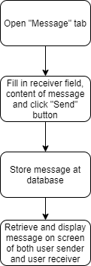

# Special Requirements

Not empty any fields.

# Preconditions

Receiver is exist.

# Postconditions

Message is display on screen at both user sender and user reveiver.

# Extension Points

No extension point.